Optometry registrant data: December 2014
Published March 2015

Introduction
The role of the Optometry Board of Australia (the Board) include:
- registering optometrist and students
- developing standards, codes and guidelines for the optometry profession
- handling notifications, complaints, investigations and disciplinary hearings
- overseeing the assessment of overseas trained practitioners who wish to practise in Australia, and
approving accreditation standards and accredited courses of study.
The Board’s functions are supported by the Australian Health Practitioner Regulation Agency (AHPRA). For information about legislation governing our operations see About AHPRA at http://www.ahpra.gov.au/About-AHPRA/What-We-Do/Legislation.aspx.
The Board has analysed its registration data and produced a number of statistical breakdowns about registrants to share with the profession and community. The Board shares these breakdowns regularly.
For more information on optometry registration, please see the Board’s website: http://www.optometryboard.gov.au/Registration.aspx

Contents
Optometry practitioners – registration type and sub type by state or territory 3
Optometry practitioners – percentage by principal place of practice 3
Optometry practitioners – endorsement by principal place of practice 4
Optometry practitioners – registration type and sub type by age group 4
Optometry practitioners – by age group 5
Optometry practitioners – registration type and sub type by gender 6
Optometry practitioners – percentage by gender 6

Optometry practitioners – registration type and sub type by state or territory
Optometry practitioner |  | Principal place of practice
Registration type | Registration sub type | ACT | NSW | NT | QLD | SA | TAS | VIC | WA | No PPP | Total
General |  | 72 | 1,605 | 28 | 974 | 252 | 83 | 1,230 | 387 | 118 | 4,749
Limited | Postgraduate training or supervised practice
 | Teaching or research |  | 3 |  |  |  |  |  |  |  | 3
Non-practising |  |  | 41 | 1 | 16 |  |  | 28 | 7 | 57 | 150
Total |  | 72 | 1,649 | 29 | 990 | 252 | 83 | 1,258 | 394 | 175 | 4,902
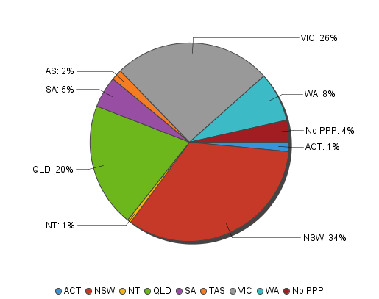
Optometry practitioners – percentage by principal place of practice

Optometry practitioners – endorsement by principal place of practice
Optometry practitioners | Principal place of practice
Endorsement type | ACT |  | NSW |  | NT |  | QLD |  | SA |  | TAS |  | VIC |  | WA |  | No PPP |  | Total
Scheduled Medicines |  | 25 |  | 407 |  | 15 |  | 387 |  | 127 |  | 54 |  | 727 |  | 158 |  | 21 |  | 1,921
% of general registrants who are endorsed |  | 34.72% |  | 25.36% |  | 53.57% |  | 39.73% |  | 50.40% |  | 65.06% |  | 59.11% |  | 40.83% |  | 17.80% |  | 39.19%
Optometry practitioners – registration type and sub type by age group
Optometry practitioners |  | Registration type/ Sub type
Age group | General |  | Limited |  | Non-practising
 |  |  | Postgraduate training or supervised practice | Teaching or research |  | Total
U - 25 | 254 |  |  |  |  | 254
25 - 29 | 713 |  |  | 3 | 10 | 726
30 - 34 | 650 |  |  |  | 17 | 667
35 - 39 | 614 |  |  |  | 17 | 631
40 - 44 | 607 |  |  |  | 27 | 634
45 - 49 | 566 |  |  |  | 18 | 584
50 - 54 | 478 |  |  |  | 23 | 501
55 - 59 | 500 |  |  |  | 17 | 517
60 - 64 | 230 |  |  |  | 8 | 238
65 - 69 | 77 |  |  |  | 7 | 84
70 - 74 | 41 |  |  |  | 3 | 44
75 - 79 | 14 |  |  |  | 2 | 16
80+ | 5 |  |  |  | 1 | 6
Total | 4,749 |  |  | 3 | 150 | 4,902
Optometry practitioners – by age group
Age Group | U - 25 | 25 - 29 | 30 - 34 | 35 - 39 | 40 - 44 | 45 - 49 | 50 - 54 | 55 - 59 | 60 - 64 | 65 - 69 | 70 - 74 | 75 - 79 | 80+
Count of Registrants | 254 | 726 | 667 | 631 | 634 | 584 | 501 | 517 | 238 | 84 | 44 | 16 | 6

Optometry practitioners – registration type and sub type by gender
Optometry Practitioner |  |  | Principal place pf practice
Gender | Registration type | Registration sub type | ACT | NSW | NT | QLD | SA | TAS | VIC | WA | No PPP | Total
Female | General |  | 37 | 860 | 14 | 471 | 110 | 27 | 643 | 167 | 57 | 2,386
 | Limited | Postgraduate training or supervised practice
 |  | Teaching or research |  | 3 |  |  |  |  |  |  |  | 3
 | Non-practising |  |  | 18 | 1 | 9 |  |  | 18 | 6 | 27 | 79
Sub Total |  |  | 37 | 881 | 15 | 480 | 110 | 27 | 661 | 173 | 84 | 2,468
Male | General |  | 35 | 745 | 14 | 503 | 142 | 56 | 587 | 220 | 61 | 2,363
 | Limited | Postgraduate training or supervised practice
 |  | Teaching or research
 | Non-practising |  |  | 23 |  | 7 |  |  | 10 | 1 | 30 | 71
Sub Total |  |  | 35 | 768 | 14 | 510 | 142 | 56 | 597 | 221 | 91 | 2,434
Total |  |  | 72 | 1,649 | 29 | 990 | 252 | 83 | 1,258 | 394 | 175 | 4,902

Optometry practitioners – percentage by gender
Optometry practitioner | Principal place of practice
Gender | ACT | NSW | NT | QLD | SA | TAS | VIC | WA | No PPP | Total
Female | 51.39% | 53.43% | 51.72% | 48.48% | 43.65% | 32.53% | 52.54% | 43.91% | 48.00% | 50.35%
Male | 48.61% | 46.57% | 48.28% | 51.52% | 56.35% | 67.47% | 47.46% | 56.09% | 52.00% | 49.65%

