Optometry registrant data: September 2015
Published November 2015

Introduction
The role of the Optometry Board of Australia (the Board) include:
- registering optometrists and students
- developing standards, codes and guidelines for the optometry profession
- handling notifications, complaints, investigations and disciplinary hearings
- overseeing the assessment of overseas trained practitioners who wish to practise in Australia, and
approving accreditation standards and accredited courses of study.
The Board’s functions are supported by the Australian Health Practitioner Regulation Agency (AHPRA). For information about legislation governing our operations see About AHPRA at http://www.ahpra.gov.au/About-AHPRA/What-We-Do/Legislation.aspx.
The Board has analysed its registration data and produced a number of statistical breakdowns about registrants to share with the profession and community. The Board shares these breakdowns regularly.
For more information on optometry registration, please see the Board’s website: http://www.optometryboard.gov.au/Registration.aspx

Contents
Optometry practitioners – registration type and sub type by state or territory 3
Optometry practitioners – percentage by principal place of practice 3
Optometry practitioners – endorsement by principal place of practice 4
Optometry practitioners – endorsement by age group 4
Optometry practitioners – registration type and sub type by age group 5
Optometry practitioners – by age group 6
Optometry practitioners – registration type and sub type by gender 7
Optometry practitioners – percentage by gender 7

Optometry practitioners – registration type and sub type by state or territory
Optometry practitioner |  | Principal place of practice
Registration type | Registration sub type | ACT | NSW | NT | QLD | SA | TAS | VIC | WA | No PPP | Total
General |  | 72 | 1,628 | 27 | 971 | 264 | 80 | 1,266 | 399 | 116 | 4,823
Limited | Postgraduate training or supervised practice |  |  |  | 1 |  |  |  |  |  | 1
 | Teaching or research |  | 1 |  |  |  |  |  |  |  | 1
Non-practising |  | 2 | 44 | 1 | 17 |  |  | 30 | 9 | 55 | 158
Total |  | 74 | 1,673 | 28 | 989 | 264 | 80 | 1,296 | 408 | 171 | 4,983

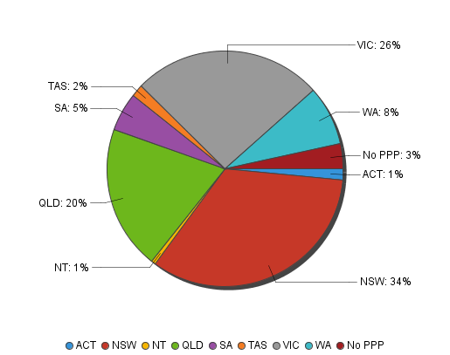
Optometry practitioners – percentage by principal place of practice

Optometry practitioners – endorsement by principal place of practice
Optometry practitioners | Principal place of practice
Endorsement type | ACT |  | NSW |  | NT |  | QLD |  | SA |  | TAS |  | VIC |  | WA |  | No PPP |  | Total
Scheduled Medicines |  | 27 |  | 481 |  | 17 |  | 405 |  | 140 |  | 54 |  | 793 |  | 176 |  | 22 |  | 2,115
% of general registrants who are endorsed |  | 37.50% |  | 29.55% |  | 62.96% |  | 41.71% |  | 53.03% |  | 67.50% |  | 62.64% |  | 44.11% |  | 18.97% |  | 100.00%

Optometry practitioners – endorsement by age group
Optometry practitioners | Practitioners who hold Scheduled Medicines endorsement
Age group | General registration | % of general registrants
U - 25 | 236 | 96.72%
25 - 29 | 600 | 83.22%
30 - 34 | 356 | 52.51%
35 - 39 | 243 | 39.84%
40 - 44 | 203 | 34.47%
45 - 49 | 166 | 27.85%
50 - 54 | 125 | 27.41%
55 - 59 | 106 | 20.31%
60 - 64 | 57 | 21.43%
65 - 69 | 21 | 24.42%
70 - 74 | 2 | 5.13%
75 - 79
80+
Total | 2,115 | 43.85%

Optometry practitioners – registration type and sub type by age group
Optometry practitioners |  | Registration type/ Sub type
Age group | General |  | Limited |  | Non-practising
 |  |  | Postgraduate training or supervised practice | Teaching or research |  | Total
U - 25 | 244 |  |  |  |  | 244
25 - 29 | 721 |  |  |  | 15 | 736
30 - 34 | 678 |  |  | 1 | 18 | 697
35 - 39 | 610 |  | 1 |  | 19 | 630
40 - 44 | 589 |  |  |  | 25 | 614
45 - 49 | 596 |  |  |  | 20 | 616
50 - 54 | 456 |  |  |  | 19 | 475
55 - 59 | 522 |  |  |  | 17 | 539
60 - 64 | 266 |  |  |  | 10 | 276
65 - 69 | 86 |  |  |  | 7 | 93
70 - 74 | 39 |  |  |  | 5 | 44
75 - 79 | 16 |  |  |  | 2 | 18
80+ |  |  |  |  | 1 | 1
Total | 4,823 |  | 1 | 1 | 158 | 4,983

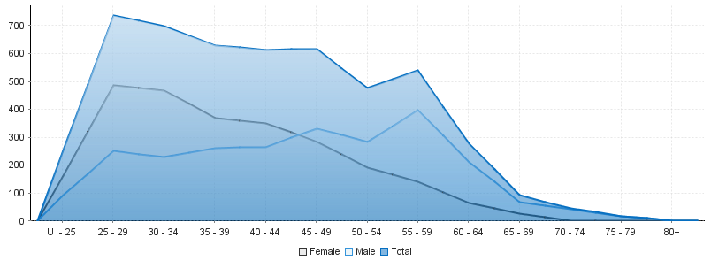
Optometry practitioners – by age group
Age group | U - 25 | 25 - 29 | 30 - 34 | 35 - 39 | 40 - 44 | 45 - 49 | 50 - 54 | 55 - 59 | 60 - 64 | 65 - 69 | 70 - 74 | 75 - 79 | 80+
Female | 156 | 486 | 468 | 369 | 350 | 284 | 191 | 141 | 65 | 25 | 1 | 1
Male | 88 | 250 | 229 | 261 | 264 | 332 | 284 | 398 | 211 | 68 | 43 | 17 | 1
Total | 244 | 736 | 697 | 630 | 614 | 616 | 475 | 539 | 276 | 93 | 44 | 18 | 1

Optometry practitioners – registration type and sub type by gender
Optometry Practitioner |  |  | Principal place of practice
Gender | Registration type | Registration sub type | ACT | NSW | NT | QLD | SA | TAS | VIC | WA | No PPP | Total
Female | General |  | 39 | 881 | 13 | 474 | 114 | 24 | 671 | 176 | 58 | 2,450
 | Limited | Postgraduate training or supervised practice |  |  |  | 1 |  |  |  |  |  | 1
 |  | Teaching or research |  | 1 |  |  |  |  |  |  |  | 1
 | Non-practising |  | 1 | 22 | 1 | 8 |  |  | 19 | 6 | 28 | 85
Sub Total |  |  | 40 | 904 | 14 | 483 | 114 | 24 | 690 | 182 | 86 | 2,537
Male | General |  | 33 | 747 | 14 | 497 | 150 | 56 | 595 | 223 | 58 | 2,373
 | Limited | Postgraduate training or supervised practice
 |  | Teaching or research
 | Non-practising |  | 1 | 22 |  | 9 |  |  | 11 | 3 | 27 | 73
Sub Total |  |  | 34 | 769 | 14 | 506 | 150 | 56 | 606 | 226 | 85 | 2,446
Total |  |  | 74 | 1,673 | 28 | 989 | 264 | 80 | 1,296 | 408 | 171 | 4,983

Optometry practitioners – percentage by gender
Optometry practitioner | Principal place of practice
Gender | ACT | NSW | NT | QLD | SA | TAS | VIC | WA | No PPP | Total
Female | 54.05% | 54.03% | 50.00% | 48.84% | 43.18% | 30.00% | 53.24% | 44.61% | 50.29% | 50.91%
Male | 45.95% | 45.97% | 50.00% | 51.16% | 56.82% | 70.00% | 46.76% | 55.39% | 49.71% | 49.09%

