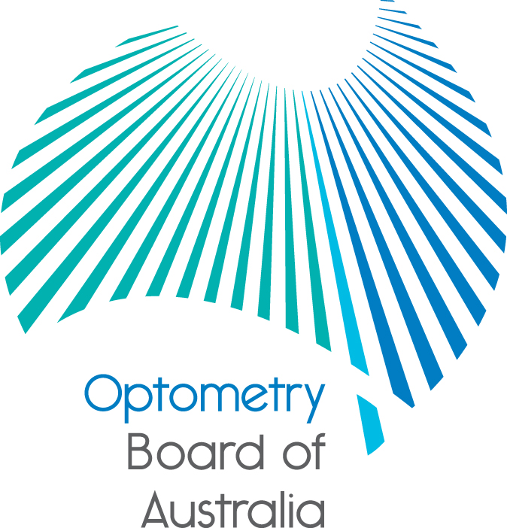

Communiqué: Optometry Board of Australia

July, August and September 2019 meetings

The 104th–106th meetings of the Optometry Board of Australia (the Board) were held on
25 July, 29 August and 26 September 2019 in Melbourne.

This communiqué outlines the issues and decisions from these meetings as well as other points of interest. We publish it on our website and email it to a broad range of stakeholders. Please forward it to your colleagues and employees who may be interested.

Board sets registration fees for 2019–20

The Board announced the national registration fee for optometrists for 2019–20 on 19 September 2019.

The Board has increased the registration fee, limiting the increase to indexation of 2.5% or $8 for the full year for optometrists, after a two-year freeze. The fee increases from $300 to $308.

This compares to 11 National Boards (Aboriginal and Torres Strait Island Health Practice, dental, medical, medical radiation practice, nursing and midwifery, occupational therapy, optometry, paramedicine, pharmacy, physiotherapy and psychology) which have increased fees by indexation (ranging from 2.5% to 3%).

A full fee schedule, including the fee arrangements for practitioners whose principal place of practice is New South Wales, is published on the Board’s website.

The Board’s decision to increase the fee for the 2019–20 period will help the Board, together with AHPRA and the Board’s Accreditation Council, undertake the increased costs of its statutory responsibilities to protect the public. All National Boards work in partnership with AHPRA to keep the public safe by:

supporting national registration to ensure only qualified, competent health practitioners can practise in Australia

developing evidence-based and practice-tested standards, codes and guidelines

investigating concerns raised about registered health practitioners, and

approving accredited programs of study leading to registration and endorsement.

The regulation of health practitioners in Australia is entirely funded by fees from registered practitioners, with no funding from governments.

Minor amendments to guidelines for use of scheduled medicines
The Optometry Board of Australia (the Board) has made minor amendments to appendices in the Guidelines for use of scheduled medicines after receiving support from a vast majority of stakeholders.
Appendix A and Appendix B of the guidelines have been amended following extensive consultation with stakeholders including government health departments.
Appendix A of the guidelines has been amended with a change in the concentration of phenylephrine to 2.5% to reflect the standard concentration mass produced for dilation and cycloplegia.
The Board has made three changes to Appendix B. Amendments have been made to:
- correctly categorise four schedule 2 drugs, Antazoline, Azelastine, Ketotifen and Levocabastine from a former incorrect category of anti-inflammatories to fall under the correct category of decongestants/anti-allergics
- amend the reference to phenylephrine from 1% to 2.5% or less, and
- to add a drug, Ganciclovir to the schedule 4 anti-infectives category in the event it becomes TGA-approved.

The remaining content in the guidelines and Appendix C are unchanged.

The Board considers the proposed revisions benefit public safety, will have a minor effect on the profession and are intended to help endorsed optometrists to deliver timely, safe and quality health services. The revised appendices to the Guidelines for use of scheduled medicines are available on the Endorsement for scheduled medicines page of the Board’s website.

Reminder for final year graduates to register early

The Board would like to remind final year graduates who have passed their final year examinations to register online with AHPRA as soon as possible. The process of obtaining registration and endorsement to practice as an optometrist may take six weeks, providing all details in your application are in order. Please ensure that the name you wish to register under is exactly the same as that recorded in your passport.

Establishment of a new working group on emerging issues

The Board has established a new internal working group to provide it with evidentiary information on emerging issues in therapeutic and clinical ophthalmic procedures. This includes issues in national and international spheres that are likely to become a part of the practice of optometry in Australia. Its role is to advise on the implications on the profession’s readiness, competencies and future training needs and to advise on the implications for the Board’s regulatory functions.

Health Profession Agreement 2019–20

Under section 26(1) of the Health Practitioner Regulation National Law (National Law), AHPRA’s Health Profession Agreement 2019–20 with the Board sets out services to be provided by AHPRA to enable the Board to carry out its functions. The agreement also sets out approaches to reciprocal obligations in relation to common understanding in achieving the objectives and guiding principles of the National Scheme. This includes a performance management framework and the Board’s annual budget and fees payable by practitioners, published on the AHPRA and National Board websites.

Important consultations now open – feedback invited

Three public consultations are now open asking for people to have their say on revised guidance to help practitioners and others understand their mandatory notification obligations, understand their obligations when advertising a regulated health service and to support a responsive and risk-based approach to supervised practice.

The Board is conducting the consultations alongside other National Boards and AHPRA on:

revised Guidelines: Mandatory notifications about registered health practitioners and Guidelines: Mandatory notifications about health students

revised Guidelines on advertising regulated health services, and

a proposed Supervised practice framework.

The Board invites optometrists and its stakeholders to provide feedback to these important public consultations. To ensure everyone has the chance to respond the closing dates for public consultation have been staggered as follows:

Public consultation on the mandatory notifications guidelines will close on 6 November 2019.

Public consultation on the advertising guidelines will close on 26 November 2019.

Public consultation on the supervised practice framework will close on 17 December 2019.

The consultation papers are available on the on the Board’s consultations web page.

.

Aboriginal and Torres Strait Islander strategy initiatives working group

The Board established an Aboriginal and Torres Strait Islander strategy initiatives working group to consider initiatives that it can undertake that are consistent with the objectives of the National Scheme Aboriginal and Torres Strait Islander Health and Cultural Safety Strategy 2020-25. Board members will participate in cultural safety training, with the Board sending a representative to the Indigenous Allied Health Australia Conference in Darwin in September 2019. It also hopes to engage with Allied Health Australia.

Continuing professional development guidelines

The Board will be publishing slight amendments to its Continuing professional development (CPD) guidelines to the revised Registration standard for CPD. The amendments provide detailed clarification about exemptions from the CPD requirements that the Board may consider in exceptional circumstances.
New practitioner experience video launched
Keep perspective; and seek help. That’s the message in the the latest video released by AHPRA and National Boards as part of the ‘Let’s talk about it’ series – Putting it in perspective: A practitioner’s notifications experience.
The video is the second practitioner experience video published this year by AHPRA and National Boards and provides a health practitioner’s first-hand account of the notification process.
AHPRA CEO Mr Martin Fletcher said the video series aims to share practitioners’ experiences, recognising what are common reactions, while proactively encouraging them to focus on likely outcomes and seek support.
‘Many practitioners have told us that they would have benefited greatly from hearing the voice of others who had gone through this experience — and come out the other side. They have also told us that when they are the subject of a notification, they immediately think they will lose their registration and their livelihood – that it’s a catastrophe.’
‘We understand that people may feel this way. However, our data show a different story. While we have a clear focus on patient safety, many notifications end without the need for regulatory action and are often closed following initial assessment, without the need for an extended investigation.’ Mr Fletcher said.
In the video, a surgeon describes his feelings of guilt and anxiety after a poor patient outcome and the notification that followed. As time went on, his worries increased, and he found it difficult to maintain a realistic perspective about what was likely to occur. He reflects on the value of speaking with family and friends, as well as the ongoing support of his GP and a psychologist.
Read the full media release.
Cultural safety training provider announced
PricewaterhouseCoopers Indigenous Consulting Pty Limited (PIC) in partnership with Griffith University First Peoples Health Unit will deliver cultural safety training to Board and committee members as well as Australian Health Regulation Agency (AHPRA) staff. This appointment is the outcome of a competitive tender process. Cultural safety training is an important first step to ensure that AHPRA and the Boards are working to help health practitioners nationally understand their own connection to culture and unconscious biases, and how these are likely to influence their work.
AHPRA CEO Mr Martin Fletcher said the training is an important milestone and is part of the agency’s commitment to support health equity for all Australians, which was publicly made by AHPRA and 36 other signatories in the National Scheme’s Statement of intent last year.
‘One of our strategic priorities is helping to embed cultural safety into the health system through our work with over 740,000 registered health practitioners across Australia.
‘We want to be a regulator who deeply understands cultural safety and what it means for our work and we want to partner with others to build a culturally safe registered health practitioner workforce across Australia,’ Mr Fletcher said.
National Scheme Aboriginal and Torres Strait Islander Health Strategy Group member and Aboriginal and Torres Strait Islander Health Practice Board of Australia Chair, Ms Renee Owen, said everyone has a part to play to achieve health equity.
‘We all have a responsibility to understand cultural safety so that we can work to eliminate racism from the health system and enable health equity for Aboriginal and Torres Strait Islander Peoples. This training is an important step towards ensuring that the regulation of health practitioners is culturally safe’, Ms Owen said.
This unique Aboriginal-led collaboration between PwC's Indigenous Consulting, Griffith University's First Peoples Health Unit and the National Scheme Aboriginal and Torres Strait Islander Strategy Group will provide a world class, bespoke cultural safety training program supporting the necessary culture transformation of Australia's health professions.
The training, to be provided by PIC in partnership with Griffith University First Peoples Health Unit, will be rolled out from the end of 2019.
Advertising your regulated health service
To protect consumers, the National Law includes provisions about advertising regulated health services. The Board has recently included a list of resources on the Board website that you might find helpful for understanding and meeting your advertising obligations.
Advertising is actions by people or businesses to draw attention to their services. The ways people and businesses can promote services are almost limitless and include all forms of printed and electronic media.
If you are advertising a regulated health service, your advertising must not:
- be false, misleading or deceptive, or likely to be misleading or deceptive
- offer a gift, discount or other inducement, unless the terms and conditions of the offer are also stated
- use testimonials or purported testimonials about the service or business
- create an unreasonable expectation of beneficial treatment, or
- directly or indirectly encourage the indiscriminate or unnecessary use of regulated health services.
If you’re not sure you’re meeting your obligations, or if you’ve been contacted by AHPRA about your advertising there are steps you can follow to make sure you comply with your professional and legal obligations.
For further details see AHPRA’s advertising resources on their website.

Are your contact details up to date?

It is important that your contact details are up to date to receive renewal reminders from AHPRA and information from the Board. You can check your details via the Login icon at the top right of the AHPRA website. Email accounts need to be set to receive communications from AHPRA and the Board to avoid misdirection to an account junk box.

Follow AHPRA on social media

Connect with AHPRA on Facebook, Twitter or LinkedIn to receive information about important topics for your profession and participate in the discussion.

Further information

We publish a range of information about registration and our expectations of you as an optometrist on our website at www.optometryboard.gov.au or www.ahpra.gov.au.

For more details or help with questions about your registration, notifications or other matters relevant to the National Scheme, refer to information published on www.ahpra.gov.au or contact AHPRA online, or call 1300 419 495

Ian Bluntish

Chair, Optometry Board of Australia

October 2019

The Optometry Board of Australia is the regulator of optometrists in Australia and acts to protect the public by ensuring that suitably qualified and competent optometrists are registered. The Board is responsible for developing registration standards, codes and guidelines for optometrists and managing notifications (complaints)* about optometrists and optometry students. The Board does this through its powers under the Health Practitioner Regulation National Law, as in force in each state and territory, and the National Registration and Accreditation Scheme, supported by the Australian Health Practitioner Regulation Agency (AHPRA). The Board’s work in regulating Australia’s optometrists in the public interest is underpinned by regulatory principles, which encourage a responsive, risk-based approach to regulation.

*Except in NSW and Qld which have co-regulatory arrangements.

