Guidelines: Continuing professional development

Effective from:1 December 2020
Introduction
These guidelines provide information about how to meet the Optometry Board of Australia’s (the Board) minimum annual continuing professional development (CPD) requirements outlined in the Registration standard: Continuing professional development (CPD standard). You are expected to understand and apply these guidelines together with the CPD standard.
The public have the right to expect that optometrists will provide competent and up-to-date services. CPD helps optometrists maintain their competence and to provide safe and effective health services.
Do these guidelines apply to me?
These guidelines apply to all registered optometrists, except those with student and non-practising registration.
What must I do?
You must undertake a minimum of 20 hours of CPD to meet the Board’s registration standard each year.
Summary
These guidelines will help you:
- understand the importance of CPD in staying up to date, maintaining safe practice and improving patient outcomes
- choose effective CPD that meets the registration standard
- understand the cardiopulmonary resuscitation (CPR) training that you must do
- understand the additional 10 hours of CPD required if you are an optometrist who holds an endorsement for scheduled medicines
- understand what an absence from practice means, and
keep a CPD portfolio, by providing a template record of your learning goals, CPD activities and reflections.
Effective CPD and why it is important
Learning and development occurs throughout an optometrist’s career. CPD is an important foundation of lifelong learning and helps optometrists to maintain their competence to practise.
Effective CPD promotes genuine learning. Genuine learning occurs when you apply what you have learned in your practice. It facilitates more effective clinical care, leading to safer outcomes for patients and clients.
Research indicates that CPD may be more effective when it involves planning and reflection. Reflection means thinking carefully about your CPD, what you learned and how you might use it to improve your practice as an optometrist. The CPD standard requires you to record your reflections on how CPD has affected your practice.
Benefits of interactive and interprofessional CPD
The CPD standard requires you to complete at least five hours of interactive CPD activities, as there is some evidence that this facilitates effective learning. It also helps to maintain connections with other practitioners and contemporary practice. Interactive CPD activities are any activities that involve other practitioners, such as face-to-face education in person, or through technologies such as web-conferencing.
Interprofessional CPD activities can also have benefits by supporting effective interprofessional practice which, in turn, optimises health services, strengthens health systems and improves health outcomes.
CPD activities
All CPD which helps you maintain competence, stay up to date and is relevant to your scope of practice will meet the standard. Practitioners are expected to practise within their education and competencies.
The Board does not endorse/accredit CPD providers or activities.
When selecting CPD activities you should consider:
- the qualifications, credentials and experience of the provider
- selecting a range of topics and activities over time, and
choosing activities that are consistent with the Board’s other standards and guidance.
The Board recognises the differences in quality of CPD activities and recommends that optometrists undertake a variety of CPD activities.
CPD may include a maximum of five hours’ CPD on non-scientific/non-clinical CPD activities (including CPD activities relating to optical goods and equipment) that is relevant to practice and improves the management of patients in a tangible way.
Learning occurs through a wide variety of CPD activities. Examples include, but are not limited to:
- higher education/accredited courses
- formative assessment
- conferences, forums and seminars
- undertaking research and presentation of work
- online learning and internet research
- written reflections on experience in day-to-day clinical practice
- reading books, publications and journals relevant to your practice
- quality assurance activities, such as accreditation, clinical audit or review of records
- participation in committees relevant to your practice
- work-based learning contracts and employment related professional development
- professional or interprofessional interactions such as meetings e.g. case reviews, clinical forums (may be online or face-to-face)
- activities that address appropriate communication, health record keeping and boundary issues, and
activities that address current or emerging health priority areas, for example, cultural safety, particularly for Aboriginal and Torres Strait Islander Peoples. Another example is effectively identifying and responding to family violence.
Undertaking your day-to-day routine work duties cannot be counted as CPD.

Cardiopulmonary resuscitation
You must have completed training for cardiopulmonary resuscitation (CPR) within the previous three registration periods, in addition to the minimum 20 hours of CPD required.
CPR training can be obtained from a number of Australian registered training organisations (RTOs) that provide CPR training that is equivalent to the CPR guidelines established by the Australian Resuscitation Council.
Evidence of training
You must have a current certificate or other evidence of having successfully completed the training, issued by the RTO. A certificate of attainment is the official acknowledgement from the RTO that you have completed the course. You will need to keep evidence (most commonly a certificate of completion) of the most recent training you completed and provided to the Board if requested for audit or other purposes.
Endorsement for scheduled medicines
Optometrists who hold an endorsement for scheduled medicines under section 94 of the Health Practitioner Regulation National Law, as in force in each state and territory (the National Law) must complete an additional 10 hours of CPD over the registration period in education related to the endorsement, including a minimum of two hours of CPD in an interactive setting with other practitioners.
A CPD activity relevant to scheduled medicines endorsement has been defined by the Board as an educational activity that meets the learning needs of the optometrist relevant to any stage of therapeutic management, as described below.
Therapeutic management involves the following stages:
- patient assessment
- differential diagnosis of conditions of the eye
- development of a management plan
- appropriate choice of medicines (this may involve writing a prescription, ceasing medicines, dose adjustment and advising on over-the-counter medicine)
- advice to the patient about the appropriate use of the medication
- development of a treatment plan
- monitoring outcome
- administration
- supply if required and completing any necessary documentation, and
understanding and engaging in collaborative care models with other health professionals.
Planning and reflection
The CPD standard requires you to:
- plan and record your learning goals and the activities that you will do to meet these goals, and
complete the CPD activities and record a reflection on how they affect your practice.

When planning your CPD you may find it useful to:
- review best practice standards or evidence-based practice. This will enable you to evaluate and improve your level of competency, treatment plan, patient communication or service delivery
- identify changes in the profession, including standards of care
- undertake a self-assessment to identify possible areas for improvement. This will help you to improve your practice to meet current standards using evidence-based practice or best practice standards
- identify how you could further develop competency or strengths in areas of particular interest or aptitude, and
identify opportunities for interactive and interprofessional CPD.
You may also wish to consider current or emerging health priorities, and should also consider any priority areas identified by the Board, for example, cultural safety for Aboriginal and Torres Strait Islander Peoples.
There is good evidence suggesting that reflecting on how your CPD relates to your practice may improve your learning. This can be done by:
- briefly summarising the CPD activities you have completed
- assessing your progress against your learning goals, and
describing how you have used what you learned in your practice.
Reflecting on your learning will help you set learning goals for the coming year as part of the ongoing CPD cycle.
It is often helpful to discuss your CPD planning with colleagues, mentors and/or supervisors as you may not always identify your own areas for improvement. Patient feedback may also be helpful in identifying areas where you need further professional development.
A template portfolio that can help you record your learning goals, your CPD activities and your reflections can be found on the Board’s website. Examples of completed CPD portfolios are also published on the Board’s website.
It is your responsibility to make sure you meet the CPD standard. You must undertake the required minimum number of CPD hours and your CPD portfolio must include planning and reflection.
The diagram below demonstrates the CPD cycle. 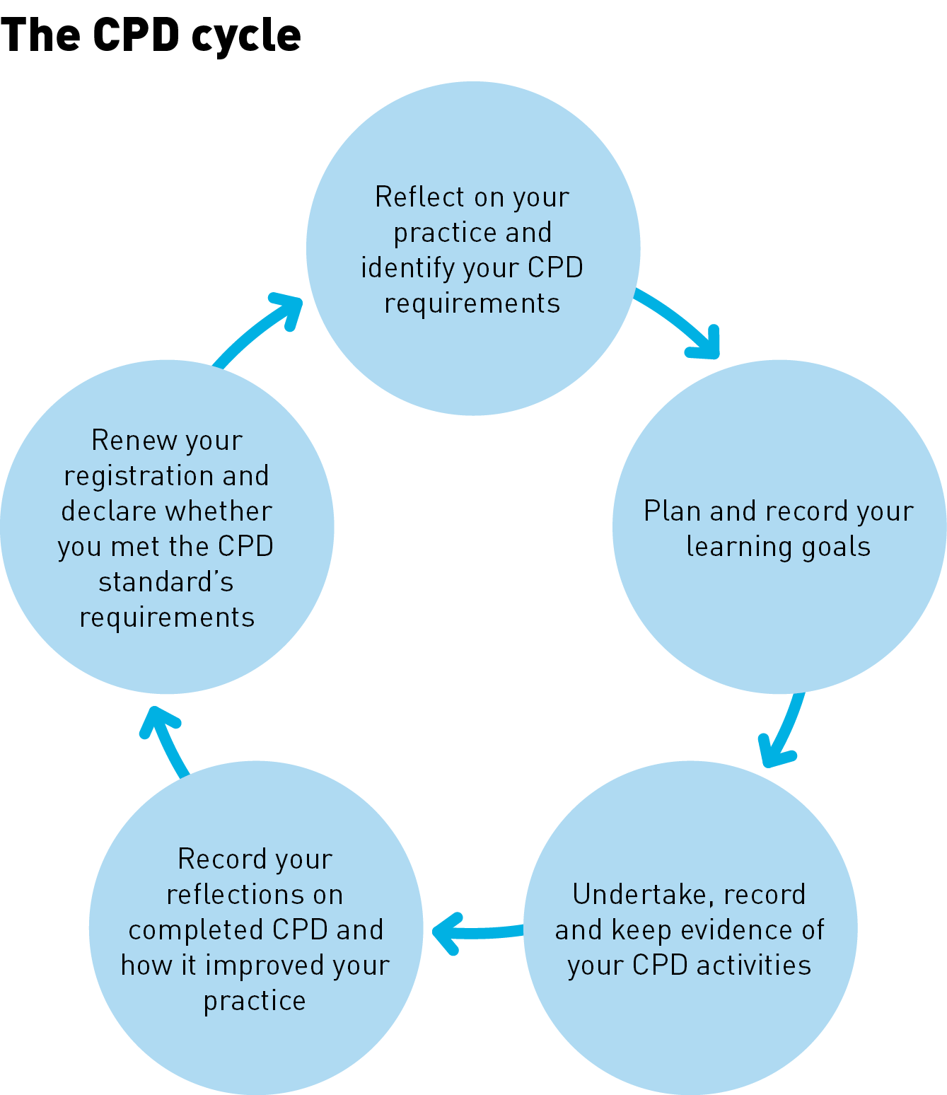
Record keeping
The CPD standard requires you to keep your CPD portfolio for at least five years from the date you completed the CPD cycle. The record must be available for audit or if required by the Board as part of an investigation arising from a notification (complaint).
You must also keep evidence of CPD activities completed, such as:
- certificates of attainment or attendance, and
your notes from the CPD activity such as conducting a literature review, or reading case studies or journal articles. In this example, it is expected that these notes will provide a comprehensive summary of the key points of the review and reflect your learning from this activity.
Pro rata CPD
Optometrists who are registered part-way through a registration period must complete a minimum of five hours of CPD for every three months of registration remaining in the registration period.
Exemption
The Board believes the range of activities and the time frame provided to meet the CPD requirements is flexible enough for optometrists to meet the requirements, other than in exceptional circumstances.
However, under the Registration standard: Continuing professional development, the Board may consider and/or grant a full or partial exemption or variation from the CPD requirements in exceptional circumstances. Exceptional circumstances for exemptions will only be considered where there is compelling evidence that the circumstances have prevented the practitioner from practising and created a significant obstacle to the optometrist’s ability to complete CPD.
In the case of parental leave the Board may grant a full or partial exemption or variation from the CPD requirements if the circumstances associated with an absence from practice are sufficient to prevent the practitioner from undertaking their CPD. The optometrist would need to provide compelling reasons to the Board supported by evidence to show why they are prevented from meeting their CPD requirements. The assessment for granting full or partial exemptions from the CPD requirements is done on a case by case basis and will depend on the individual’s circumstances and reasons provided. Further information about exemptions can be found in the Board’s Fact sheet: CPD exemptions.
You should submit an Application for exemption form to the Board as soon as possible after you identify the need for an exemption. The application must include the nature of, evidence for, and time period of the exceptional circumstances involved.
Optometrists are required to complete a pro-rata level of CPD requirements for any part of the registration period for which they practise the profession. Optometrists must complete five hours of CPD for every three months of registration remaining in the registration period.
As a general principle, financial hardship or remote location are not adequate grounds for a partial exemption, as there are sufficient CPD activities in a range of formats available to overcome these obstacles. Evidence of a history of undertaking CPD activities will be taken into account by the Board when assessing applications for exemption.
The Board will only consider an exemption in one year of any four-year period.
Absence from practice
If you take a period of leave while you remain registered to practise, you are still required to meet the Board’s CPD standard unless you are granted an exemption.
If you move to non-practising registration or don’t maintain your registration, before you re-apply for registration to practise you are encouraged to assess what changes have occurred in your profession and if there is any professional development you need to do to ensure that you are prepared to return to practice.
Compliance
As the CPD standard explains:
- when you renew your registration, you are required to declare whether you have met the requirements of the CPD standard
- your compliance with this standard may be audited from time to time, which involves a review of your CPD portfolio including your CPD goals, activities completed, and your reflection on those activities, CPR certificate of completion, or any other information the Board requires, and
failure to comply with the CPD standard requirements, CPR training requirements, or any other information the Board requires, may result in action being taken against you by the Board to protect the public.
Important note: making a false declaration when you renew your registration is a serious matter which may result in action taken against you by the Board.
Authority
The Board has developed these guidelines under section 39 of the Health Practitioner Regulation National Law, as in force in each state and territory (the National Law).
Guidelines approved by the Board may be used as evidence of what constitutes appropriate professional conduct or practice for optometrists in proceedings against a health practitioner under the National Law, or a law of a co-regulatory jurisdiction.
Definitions
Cardiopulmonary resuscitation (CPR) is the technique of chest compressions combined with rescue breathing. The purpose of cardiopulmonary resuscitation is to temporarily maintain a circulation sufficient to preserve brain function until specialised treatment is available (Australian Resuscitation Council 2016).
Continuing professional development (CPD) is the means by which members of the profession maintain, improve and broaden their knowledge, expertise and competence, and develop the personal qualities required throughout their professional lives.
Competence means having the qualifications and ability to perform a specific role. It involves a complex interaction and integration of knowledge, skills, professional behaviours and judgement.
CPD cycle means the registration year in which the CPD was completed.
CPD portfolio means information about your CPD plans/goals, the CPD activities you have done, evidence of completion of the CPD activities and your reflection on their effect on your practice. It can be hard copy and/or electronic or a combination.
Interactive means learning that involves a two-way flow of information and occurs with other practitioners, such as face-to-face or interactive online education.
Interprofessional education means learning that occurs when individuals from two or more professions learn about, from and with each other to enable effective collaboration and improve health outcomes.
Parental leave means leave that can be taken when an employee gives birth, an employee’s spouse or de facto partner gives birth, or an employee adopts a child under 16 years of age.
Practice means any role, whether remunerated or not, in which the individual uses their skills and knowledge as a health practitioner in their profession. Practice in this context is not restricted to the provision of direct clinical care. It also includes using professional knowledge (working) in a direct non-clinical relationship with clients, working in management, administration, education, research, advisory, regulatory or policy development roles, and any other roles that impact on the safe, effective delivery of services in the profession.
Reflection means thinking about what you do in order to improve your learning and practice.
Scope of practice means the professional role and services that an individual health practitioner is educated and competent to perform.

Summary of research published under Codes, guidelines and policies on the Board’s website
1 Note that the ‘Perform CPR’ certificate expires after one year but for the purposes of the CPD requirement will be valid for three years.
As updated from time to time by the Board.
Optometrists who prescribe scheduled medicines should observe the Quality Use of Medicines. The complete strategy can be found at www.health.gov.au.
Optometrists with a scheduled medicines endorsement must be familiar and comply with the current state and territory medicines or poisons legislative requirements in the jurisdictions in which they practise.
Fair Work Ombudsman, accessed 1 November 2017 (www.fairwork.gov.au/leave/maternity-and-parental-leave)

