Optometry Board of Australia

Registrant Data

Reporting period: December 2015

Table of contents
Introduction 3
Principal Place of Practice 4
1. Registration Type 4
2. Endorsements 5
Age Group 6
3. Registration Type and Sub type 6
Gender 7
4. Registration Type 7
5. Percentage 7

Introduction
The role of the Optometry Board of Australia (the Board) include:
- registering optometrists and students
- developing standards, codes and guidelines for the optometry profession
- handling notifications, complaints, investigations and disciplinary hearings
- overseeing the assessment of overseas trained practitioners who wish to practise in Australia, and
- approving accreditation standards and accredited courses of study.
The Board’s functions are supported by the Australian Health Practitioner Regulation Agency (AHPRA). For information about legislation governing our operations see About AHPRA at http://www.ahpra.gov.au/About-AHPRA/What-We-Do/Legislation.aspx.
The Board has analysed its registration data and produced a number of statistical breakdowns about registrants to share with the profession and community. The Board shares these breakdowns regularly.
For more information on optometry registration, please see the Board’s website: http://www.optometryboard.gov.au/Registration.aspx

Principal Place of Practice
- Registration Type
  - Registration Type by Principal Place of Practice
Registration Type | Registration Sub-type | ACT | NSW | NT | QLD | SA | TAS | VIC | WA | No PPP | Total
General |  | 73 | 1,676 | 29 | 1,002 | 272 | 81 | 1,285 | 407 | 116 | 4,941
Limited | Postgraduate training or supervised practice |  |  |  | 1 |  |  |  |  |  | 1
 | Teaching or research |  | 3 |  |  |  |  |  |  |  | 3
Non-practising |  | 2 | 43 | 1 | 17 | 1 | 1 | 35 | 10 | 59 | 169
Total |  | 75 | 1,722 | 30 | 1,020 | 273 | 82 | 1,320 | 417 | 175 | 5,114

  - Registration Type by Principal Place of Practice Percentages
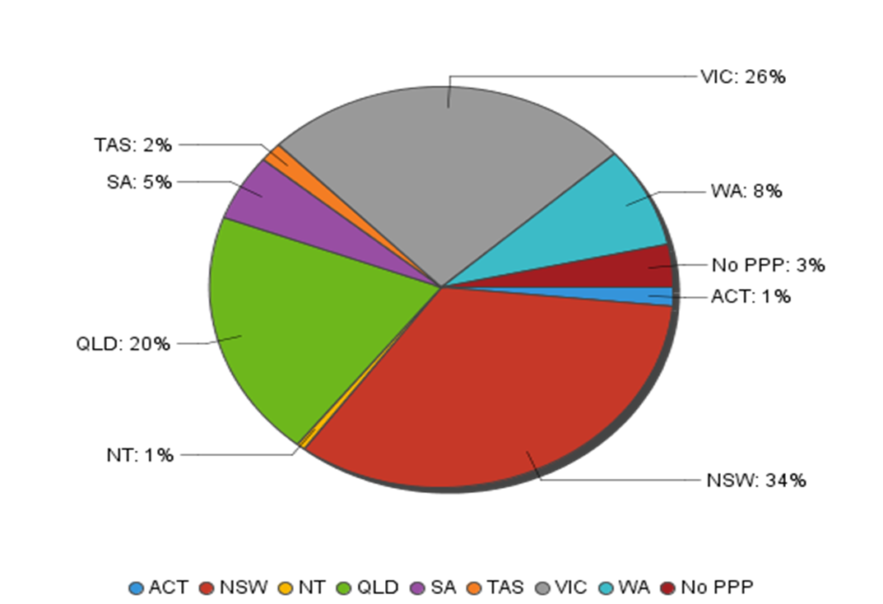
- Endorsements
  - Endorsements
Endorsement | ACT | NSW | NT | QLD | SA | TAS | VIC | WA | No PPP | Total
Scheduled Medicines | 31 | 548 | 19 | 444 | 149 | 55 | 821 | 188 | 26 | 2,281
% of general registrants who are endorsed | 42% | 33% | 66% | 44% | 55% | 68% | 64% | 46% | 22% | 46%

  - Endorsements by Age Group
Age Group | Scheduled Medicines | % of General Registrants
U - 25 | 291 | 99%
25 - 29 | 648 | 85%
30 - 34 | 375 | 55%
35 - 39 | 256 | 41%
40 - 44 | 216 | 36%
45 - 49 | 175 | 29%
50 - 54 | 118 | 27%
55 - 59 | 118 | 23%
60 - 64 | 60 | 21%
65 - 69 | 22 | 26%
70 - 74 | 2 | 5%
Total | 2,281 | 46%

Age Group
- Registration Type and Sub type
  - Registrants by Age Group
Age Group | General | Limited |  | Non-practising | Total
 |  | Postgraduate training or supervised practice | Teaching or research
U - 25 | 293 |  |  |  | 293
25 - 29 | 759 |  | 2 | 15 | 776
30 - 34 | 676 |  | 1 | 19 | 696
35 - 39 | 626 | 1 |  | 18 | 645
40 - 44 | 592 |  |  | 25 | 617
45 - 49 | 605 |  |  | 21 | 626
50 - 54 | 442 |  |  | 24 | 466
55 - 59 | 523 |  |  | 19 | 542
60 - 64 | 281 |  |  | 11 | 292
65 - 69 | 84 |  |  | 9 | 93
70 - 74 | 43 |  |  | 5 | 48
75 - 79 | 17 |  |  | 2 | 19
80+ |  |  |  | 1 | 1
Total | 4,941 | 1 | 3 | 169 | 5,114

  - Registrants by Age Group
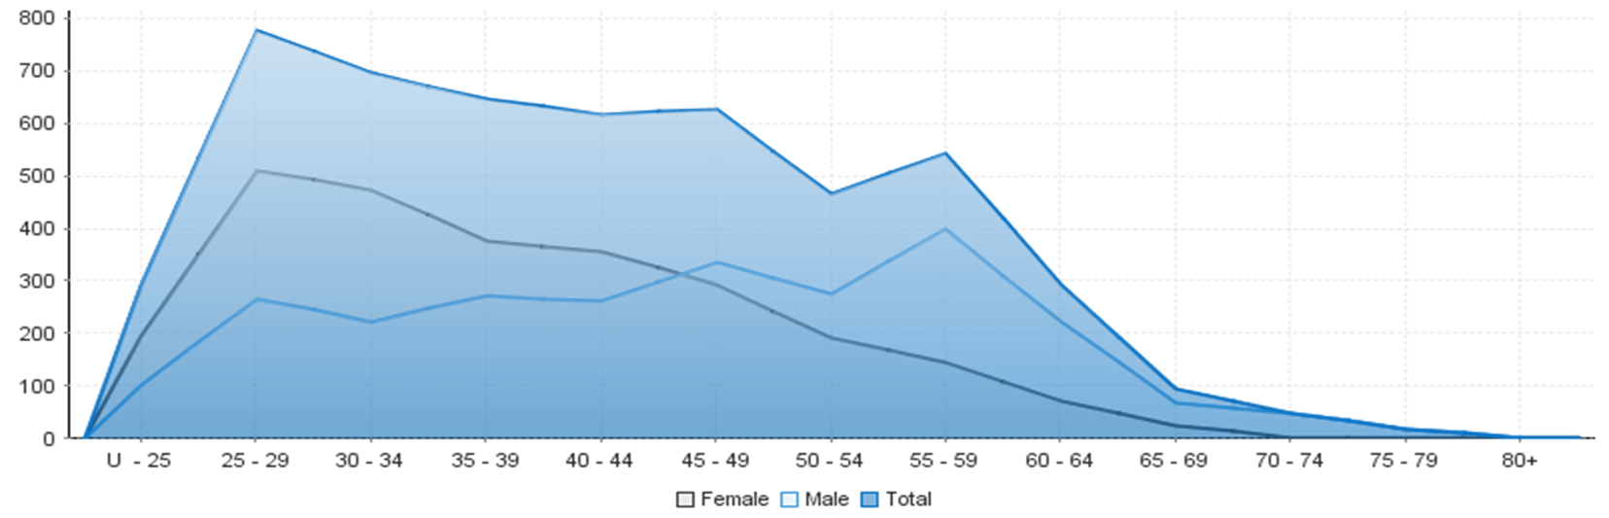

Gender
- Registration Type
  - Gender by state and territory by registration type
Gender | Registration Type | Sub Type | ACT | NSW | NT | QLD | SA | TAS | VIC | WA | No PPP | Total
Female | General |  | 41 | 910 | 14 | 502 | 120 | 24 | 686 | 180 | 58 | 2,535
 | Limited | Postgraduate training or supervised practice |  |  |  | 1 |  |  |  |  |  | 1
 |  | Teaching or Research |  | 3 |  |  |  |  |  |  |  | 3
 | Non-practising |  | 1 | 21 | 1 | 8 | 1 | 1 | 20 | 7 | 32 | 92
Total Female |  |  | 42 | 934 | 15 | 511 | 121 | 25 | 706 | 187 | 90 | 2,631
Male | General |  | 32 | 766 | 15 | 500 | 152 | 57 | 599 | 227 | 58 | 2,406
 | Non-practising |  | 1 | 22 |  | 9 |  |  | 15 | 3 | 27 | 77
Total Male |  |  | 33 | 788 | 15 | 509 | 152 | 57 | 614 | 230 | 85 | 2,483
Total |  |  | 75 | 1,722 | 30 | 1,020 | 273 | 82 | 1,320 | 417 | 175 | 5,114

- Percentage
  - Registrants by Gender Percentages
Gender | ACT | NSW | NT | QLD | SA | TAS | VIC | WA | No PPP | Total
Female | 56% | 54% | 50% | 50% | 44% | 30% | 53% | 45% | 51% | 51%
Male | 44% | 46% | 50% | 50% | 56% | 70% | 47% | 55% | 49% | 49%

