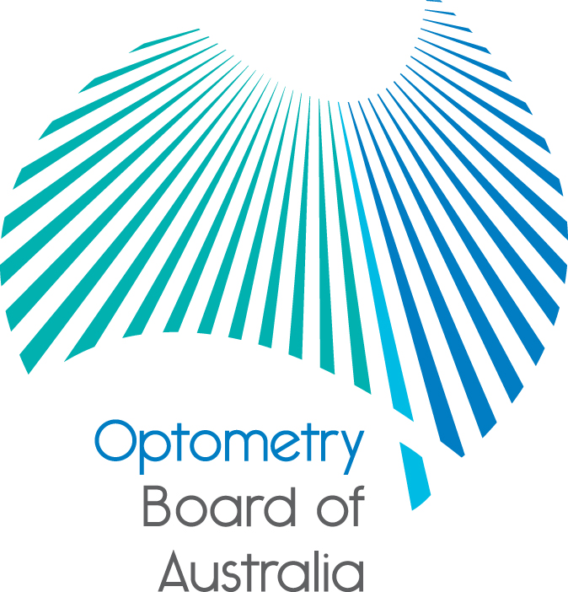
Communiqué: Optometry Board of Australia

August 2017 meeting
The 85th meeting of the Optometry Board of Australia (the Board) was held on 24 August 2017 at the Australian Health Practitioner Regulation Agency (AHPRA) National office in Melbourne.
This communiqué outlines the issues and decisions from this meeting as well as other points of interest. We publish it on our website and email it to a broad range of stakeholders. Please forward it to your colleagues and employees who may be interested.
Board to co-host Early Career Optometrist networking event and the SA Blue Sky Conference 2017
The Board will co-host an Early Career Optometrist networking event on 9 November 2017, which is the night before the SA Blue Sky Conference 2017. This is an opportunity for early career optometrists, final year university students and other conference delegates to meet Board members, learn the difference between the role of the Board and the role of Optometry Australia (OA), how optometrists, the Board and OA can shape the future of optometry regulation and how to become a Board or Committee member.
The Board Chair also will be providing a short presentation on the current work of the Board at the SA Blue Sky Conference. There will be ample opportunity for delegates to ask questions and meet Board members, including community Board members at their exhibit space.
Scheduled Medicines Advisory Committee member vacancy
The Board thanked Professor Lisa Nissen for her contributions to the Scheduled Medicines Advisory Committee (the Committee). Professor Nissen resigned from the Committee following her appointment to the recently established AHPRA Scheduled Medicines Expert Committee (SMEC). More information about the role can be found on AHPRA’s website.
A call will be made soon for applications for appointment to the Committee of the Board. The multi-professional committee advises the Board on the administration or prescribing of scheduled medicines by optometrists. The committee terms of reference have recently been reviewed and can be found on the Board’s website.
Appointments are made by the National Board under the Health Practitioner Regulation National Law, as in force in each state and territory (the National Law). Applications will be assessed by a selection advisory panel.
The Board will invite applications from registered pharmacists seeking to fill the vacancy for the pharmacist member of the Committee.
More information about the role, eligibility requirements and the application process, will be found on the AHPRA Committee member recruitment website when available.
COAG Health Council meeting communiqué: progressing amendments to the National Law
The federal and state and territory health ministers met in Brisbane on 4 August 2017 at the COAG Health Council to discuss a range of national health issues. The meeting was chaired by the Victorian Minister for Health, the Hon. Jill Hennessy. AHPRA CEO Martin Fletcher attended the Australian Health Workforce Ministerial Council (the Ministerial Council) meeting which brings together all health ministers throughout Australia to provide oversight for the work of the National Registration and Accreditation Scheme. AHPRA and the National Boards provide a regular update to the Ministerial Council on our work.
The meeting included an agreement by health ministers to proceed with amendments to the National Law to strengthen penalties for offences committed by people who hold themselves out to be a registered health practitioner, including those who use reserved professional titles or carry out restricted practices when not registered. Ministers also agreed to proceed with an amendment to introduce a custodial sentence with a maximum term of up to three years for these offences. These important reforms will be fast tracked to strengthen public protection under the National Law. Preparation will now begin on a draft amendment bill, with a view to being introduced to the Queensland Parliament in 2018.
Ministers also discussed mandatory reporting provisions for treating health practitioners, agreeing that protecting the public from harm is of paramount importance as is supporting practitioners to seek help and treatment for their health concerns, including for their mental health and well-being. They agreed practitioners should be able to confidentially seek treatment for health issues while preserving the requirement for patient safety. It was agreed that the Australian Health Ministers’ Advisory Council will recommend a nationally consistent approach to mandatory reporting following a consultation process with consumer and practitioner groups. A proposal on mandatory reporting is expected to be considered at the November 2017 meeting of the COAG Health Council.
The Council produces a communiqué from its meeting which can be accessed on the AHPRA website.
Are your contact details up to date?
It is important that your contact details are up to date to receive renewal reminders from AHPRA and information from the Board. You can check your details via the Login icon at the top right of the AHPRA website. Email accounts need to be set to receive communications from AHPRA and the Board to avoid misdirection to an account junk box.
Follow AHPRA on social media
Connect with AHPRA on Facebook,Twitter or LinkedIn to receive information about important topics for your profession and participate in the discussion.

Further information
We publish a range of information about registration and our expectations of you as an optometrist on our website at www.optometryboard.gov.au or www.ahpra.gov.au.
For more details or help with questions about your registration, notifications or other matters relevant to the National Registration and Accreditation Scheme, refer to information published on www.ahpra.gov.au or contact AHPRA, send an online enquiry form or call on 1300 419 495.
Ian Bluntish
Chair, Optometry Board of Australia
August 2017

The Optometry Board of Australia is the regulator of optometrists in Australia and acts to protect the public by ensuring that suitably qualified and competent optometrists are registered. The Board is responsible for developing registration standards, codes and guidelines for optometrists and managing notifications (complaints)* about optometrists and optometry students. The Board does this through its powers under the Health Practitioner Regulation National Law, as in force in each state and territory, and the National Registration and Accreditation Scheme, supported by the Australian Health Practitioner Regulation Agency (AHPRA). The Board’s work in regulating Australia’s optometrists in the public interest is underpinned by regulatory principles, which encourage a responsive, risk-based approach to regulation.
*Except in NSW and Qld which have co-regulatory arrangements.

