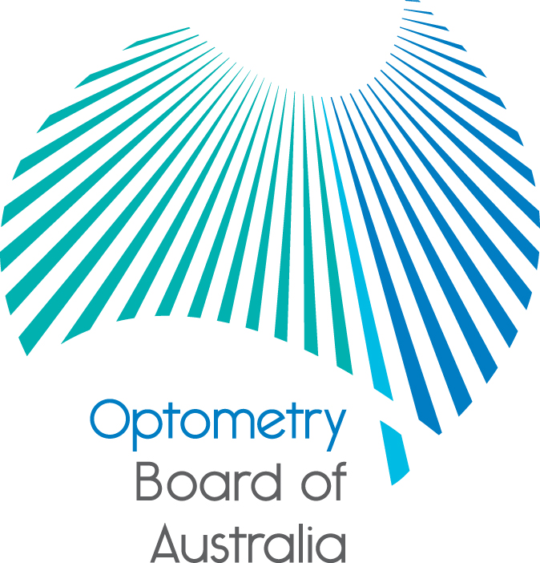
Communiqué: Optometry Board of Australia

July 2017 meeting
The 84th meeting of the Optometry Board of Australia (the Board) was held on 27 July 2017 at the Australian Health Practitioner Regulation Agency (AHPRA) National office in Melbourne.
This communiqué outlines the issues and decisions from this meeting as well as other points of interest. We publish it on our website and email it to a broad range of stakeholders. Please forward it to your colleagues and employees who may be interested.
Quarterly registration data released
The Board publishes quarterly data profiling Australia’s optometry workforce, including a number of statistical breakdowns about registrants. The Board has released its March 2017 registration data on the Board’s Statistics page.
Regulatory stakeholders to gather at CLEAR
The Fifth International Congress on Professional and Occupational Regulation will be held this November in Melbourne, Australia. AHPRA will join other regulatory stakeholders from around the world to share global perspectives on licensure and regulation.

Additional information about the conference is on the AHPRA website.
Advertising information available for practitioners
The Board noted that further advertising information is now available on the AHPRA website to help optometrists check and correct their advertising so they comply with legal requirements.
It includes:
- examples of non-compliant advertising by registered health practitioners and changes that would help it to comply with the National Law
- information about AHPRA’s process for managing advertising complaints, and
- a summary of advertising guidelines.

Optometrists are responsible for their advertising and must be able to substantiate any claims made that their treatments benefit patients. If in doubt about a claim, optometrists should leave it out of their advertising.
More about advertising requirements is in the Advertising resources section of the AHPRA website.
Are your contact details up to date?
It is important that your contact details are up to date to receive renewal reminders from AHPRA and information from the Board. You can check your details via the Login icon at the top right of the AHPRA website. Email accounts need to be set to receive communications from AHPRA and the Board to avoid misdirection to an account junk box.
Follow AHPRA on social media
Connect with AHPRA on Facebook,Twitter or LinkedIn to receive information about important topics for your profession and participate in the discussion.

Further information
We publish a range of information about registration and our expectations of you as an optometrist on our website at www.optometryboard.gov.au or www.ahpra.gov.au.
For more details or help with questions about your registration, notifications or other matters relevant to the National Registration and Accreditation Scheme, refer to information published on www.ahpra.gov.au or contact AHPRA, send an online enquiry form or call on 1300 419 495.
Ian Bluntish
Chair, Optometry Board of Australia
July 2017

The Optometry Board of Australia is the regulator of optometrists in Australia and acts to protect the public by ensuring that suitably qualified and competent optometrists are registered. The Board is responsible for developing registration standards, codes and guidelines for optometrists and managing notifications (complaints)* about optometrists and optometry students. The Board does this through its powers under the Health Practitioner Regulation National Law, as in force in each state and territory, and the National Registration and Accreditation Scheme, supported by the Australian Health Practitioner Regulation Agency (AHPRA). The Board’s work in regulating Australia’s optometrists in the public interest is underpinned by regulatory principles, which encourage a responsive, risk-based approach to regulation.
*Except in NSW and Qld which have co-regulatory arrangements.

The Health Practitioner Regulation National Law, as in force in each state and territory (the National Law).

