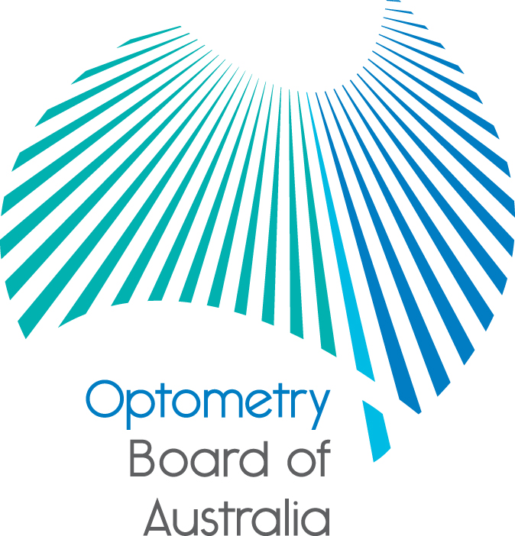
Communiqué: Optometry Board of Australia

March 2017 meeting
The 81st meeting of the Optometry Board of Australia (the Board) was held on 30 March 2017 at the Australian Health Practitioner Regulation Agency (AHPRA) National office in Melbourne.
This communiqué outlines the issues and decisions from this meeting as well as other points of interest. We publish it on our website and email it to a broad range of stakeholders. Please forward it to your colleagues and employees who may be interested.
Review of registration standard for continuing professional development and guidelines for continuing professional development for endorsed and non-endorsed optometrists
The Board is currently conducting a review of its registration standard and related guidelines for continuing professional development jointly with a number of other AHPRA National Boards. The Board regularly reviews its standard and guidelines as part of good regulatory practice to consider developments since they were last approved and whether any changes are needed to keep them current and as effective as possible.
The Board undertook preliminary consultation late last year with key stakeholders about its draft revised standard and guidelines for continuing professional development. The Board received a wide range of helpful feedback and thanks these stakeholders for taking the time to review the draft revised standard and guidelines. The Board is still analysing the feedback received and is undertaking further work including additional research.
The Board is aiming to consult publicly on the revised standard in the later half of 2017 and when ready will advise its stakeholders and publish the public consultation documents on the Board’s Current Consultations page.
The Board would like to highlight that any changes made to the approved revised registration standard and guidelines after public consultation will have a period of transition to support the profession in adapting to these changes.
Public consultation is now closed for revised endorsement for scheduled medicines registration standard and related guidelines
The Board recently released a public consultation paper on the review of the Endorsement for scheduled medicines registration standard and Guidelines for use of scheduled medicines.
The consultation closed on 31 March 2017. The consultation paper will be available on the Board’s Past Consultations page.
Optometry regulation at work: Protecting the public in 2015/16
An annual report summary that looks into the work of the Optometry Board of Australia over the year to 30 June 2016 has now been published. The report draws on data from the 2015/16 Annual Report by AHPRA and the National Boards.
More information is found in the Board’s news item.

New Registration and Notification Committee Member
The Board welcomed Ms Surahbi Verma as the new practitioner member on the Registration and Notifications Committee (RNC) and thanked Ms Stephanie Bahler for her prior contributions to the RNC. More information on the RNC can be found on the Board’s website
New accreditation publications about costs and international accreditation systems
In preparation for the Accreditation Systems Review, two new papers have been published about key aspects of the accreditation functions under the National Registration and Accreditation Scheme.
The papers provide a new analysis of accreditation costs and an international comparison of accreditation systems for registered health professions in comparable health systems.
More information is found in AHPRA’s news item. More information about the Accreditation Systems Review is found on the COAG Health Council website.
Are your contact details up-to-date?
It is important that your contact details are up to date to receive renewal reminders from AHPRA and information from the Board. You can check your details via the Login icon at the top right of the AHPRA website. Email accounts need to be set to receive communications from AHPRA and the Board to avoid misdirection to an account junk box.
Further information
We publish a range of information about registration and our expectations of you as an optometrist on our website at www.optometryboard.gov.au or www.ahpra.gov.au.
For more details or help with questions about your registration, notifications or other matters relevant to the National Registration and Accreditation Scheme, refer to information published on www.ahpra.gov.au or contact AHPRA, send an online enquiry form or call on 1300 419 495.
Ian Bluntish
Chair, Optometry Board of Australia
3 April 2017

The Optometry Board of Australia is the regulator of optometrists in Australia and acts to protect the public by ensuring that suitably qualified and competent optometrists are registered. The Board is responsible for developing registration standards, codes and guidelines for optometrists and managing notifications (complaints)* about optometrists and optometry students. The Board does this through its powers under the Health Practitioner Regulation National Law, as in force in each state and territory, and the National Registration and Accreditation Scheme, supported by the Australian Health Practitioner Regulation Agency (AHPRA). The Board’s work in regulating Australia’s optometrists in the public interest is underpinned by regulatory principles, which encourage a responsive, risk-based approach to regulation.
*Except in NSW and Qld which have co-regulatory arrangements.

