Optometry registrant data: June 2015
Published August 2015

Introduction
The role of the Optometry Board of Australia (the Board) include:
- registering optometrist and students
- developing standards, codes and guidelines for the optometry profession
- handling notifications, complaints, investigations and disciplinary hearings
- overseeing the assessment of overseas trained practitioners who wish to practise in Australia, and
approving accreditation standards and accredited courses of study.
The Board’s functions are supported by the Australian Health Practitioner Regulation Agency (AHPRA). For information about legislation governing our operations see About AHPRA at http://www.ahpra.gov.au/About-AHPRA/What-We-Do/Legislation.aspx.
The Board has analysed its registration data and produced a number of statistical breakdowns about registrants to share with the profession and community. The Board shares these breakdowns regularly.
For more information on optometry registration, please see the Board’s website: http://www.optometryboard.gov.au/Registration.aspx

Contents
Optometry practitioners – registration type and sub type by state or territory 3
Optometry practitioners – percentage by principal place of practice 3
Optometry practitioners – endorsement by principal place of practice 4
Optometry practitioners – endorsement by age group 4
Optometry practitioners – registration type and sub type by age group 5
Optometry practitioners – by age group 6
Optometry practitioners – registration type and sub type by gender 7
Optometry practitioners – percentage by gender 7

Optometry practitioners – registration type and sub type by state or territory
Optometry practitioner |  | Principal place of practice
Registration type | Registration sub type | ACT | NSW | NT | QLD | SA | TAS | VIC | WA | No PPP | Total
General |  | 71 | 1,617 | 28 | 968 | 259 | 80 | 1,222 | 395 | 118 | 4,758
Limited | Postgraduate training or supervised practice
 | Teaching or research |  | 2 |  |  |  |  |  |  |  | 2
Non-practising |  | 2 | 44 | 1 | 17 |  |  | 29 | 8 | 54 | 155
Total |  | 73 | 1,663 | 29 | 985 | 259 | 80 | 1,251 | 403 | 172 | 4,915
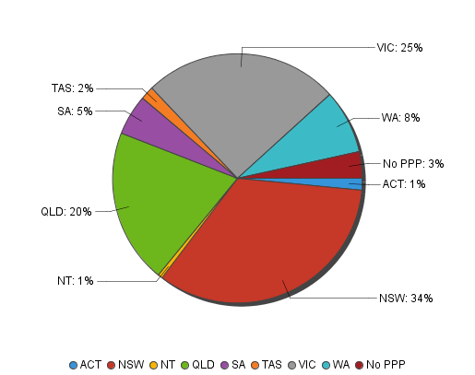
Optometry practitioners – percentage by principal place of practice

Optometry practitioners – endorsement by principal place of practice
Optometry practitioners | Principal place of practice
Endorsement type | ACT |  | NSW |  | NT |  | QLD |  | SA |  | TAS |  | VIC |  | WA |  | No PPP |  | Total
Scheduled Medicines |  | 26 |  | 453 |  | 16 |  | 396 |  | 135 |  | 54 |  | 729 |  | 170 |  | 21 |  | 2,000
% of general registrants who are endorsed |  | 36.62% |  | 28.01% |  | 57.14% |  | 40.91% |  | 52.12% |  | 67.50% |  | 59.66% |  | 43.04% |  | 17.80% |  | 40.69%

Optometry practitioners – endorsement by age group
Optometry practitioners | Practitioners who hold Scheduled Medicines endorsement
Age group | General registration
U - 25 | 216
25 - 29 | 581
30 - 34 | 330
35 - 39 | 230
40 - 44 | 187
45 - 49 | 156
50 - 54 | 124
55 - 59 | 101
60 - 64 | 55
65 - 69 | 18
70 - 74 | 2
75 - 79
80+
Total | 2,000

Optometry practitioners – registration type and sub type by age group
Optometry practitioners |  | Registration type/ Sub type
Age group | General |  | Limited |  | Non-practising
 |  |  | Postgraduate training or supervised practice | Teaching or research |  | Total
U - 25 | 227 |  |  |  |  | 227
25 - 29 | 716 |  |  | 1 | 16 | 733
30 - 34 | 663 |  |  | 1 | 18 | 682
35 - 39 | 613 |  |  |  | 18 | 631
40 - 44 | 587 |  |  |  | 24 | 611
45 - 49 | 587 |  |  |  | 19 | 606
50 - 54 | 460 |  |  |  | 18 | 478
55 - 59 | 518 |  |  |  | 20 | 538
60 - 64 | 255 |  |  |  | 7 | 262
65 - 69 | 77 |  |  |  | 7 | 84
70 - 74 | 42 |  |  |  | 5 | 47
75 - 79 | 13 |  |  |  | 2 | 15
80+ |  |  |  |  | 1 | 1
Total | 4,758 |  |  | 2 | 155 | 4,915
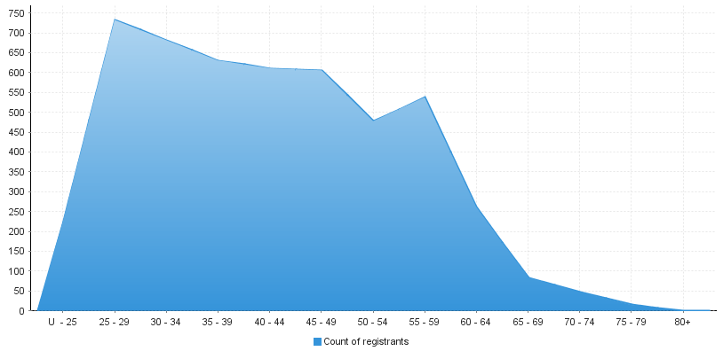
Optometry practitioners – by age group
Age group | U - 25 | 25 - 29 | 30 - 34 | 35 - 39 | 40 - 44 | 45 - 49 | 50 - 54 | 55 - 59 | 60 - 64 | 65 - 69 | 70 - 74 | 75 - 79 | 80+
Count of registrants | 227 | 733 | 682 | 631 | 611 | 606 | 478 | 538 | 262 | 84 | 47 | 15 | 1

Optometry practitioners – registration type and sub type by gender
Optometry Practitioner |  |  | Principal place pf practice
Gender | Registration type | Registration sub type | ACT | NSW | NT | QLD | SA | TAS | VIC | WA | No PPP | Total
Female | General |  | 38 | 876 | 14 | 471 | 111 | 24 | 640 | 173 | 59 | 2,406
 | Limited | Postgraduate training or supervised practice
 |  | Teaching or research |  | 2 |  |  |  |  |  |  |  | 2
 | Non-practising |  | 1 | 21 | 1 | 8 |  |  | 19 | 6 | 27 | 83
Sub Total |  |  | 39 | 899 | 15 | 479 | 111 | 24 | 659 | 179 | 86 | 2,491
Male | General |  | 33 | 741 | 14 | 497 | 148 | 56 | 582 | 222 | 59 | 2,352
 | Limited | Postgraduate training or supervised practice
 |  | Teaching or research
 | Non-practising |  | 1 | 23 |  | 9 |  |  | 10 | 2 | 27 | 72
Sub Total |  |  | 34 | 764 | 14 | 506 | 148 | 56 | 592 | 224 | 86 | 2,424
Total |  |  | 73 | 1,663 | 29 | 985 | 259 | 80 | 1,251 | 403 | 172 | 4,915

Optometry practitioners – percentage by gender
Optometry practitioner | Principal place of practice
Gender | ACT | NSW | NT | QLD | SA | TAS | VIC | WA | No PPP | Total
Female | 53.42% | 54.06% | 51.72% | 48.63% | 42.86% | 30.00% | 52.68% | 44.42% | 50.00% | 50.68%
Male | 46.58% | 45.94% | 48.28% | 51.37% | 57.14% | 70.00% | 47.32% | 55.58% | 50.00% | 49.32%

