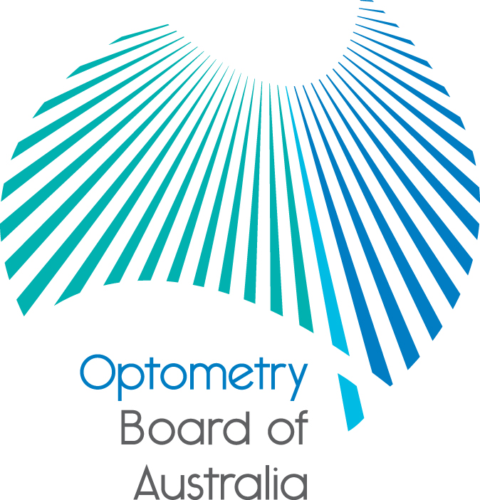
Communiqué: Optometry Board of Australia

October 2017 meeting
The 87th meeting of the Optometry Board of Australia (the Board) was held on 26 October 2017 via teleconference.
This communiqué outlines the issues and decisions from this meeting as well as other points of interest. We publish it on our website and email it to a broad range of stakeholders. Please forward it to your colleagues and employees who may be interested.
Registration renewal: Updating the national register

Registration renewal for the optometry profession will open soon and we want to let you know that this year it will include an extra step.

When completing your renewal online, you will be asked to check that your qualification(s) are recorded correctly on the national register of practitioners.

We are including this as part of online renewal to make it easy for you to confirm and update these details if required. You will be helping us to maintain the integrity of the national register, which helps to protect the public.

The national register keeps the public safe in the knowledge that its health practitioners are registered and qualified. Under the Health Practitioner Regulation National Law, as in force in each state and territory, the national register should include details of any qualification you have relied on to obtain registration.
Look out for an email from AHPRA soon inviting you to renew online.
Board sets fee for 2017/18

The Optometry Board of Australia (the Board) has announced the national registration fee for optometrists for 2017/18.
The Board has frozen the registration fee at $300. The fee for practitioners whose principal place of practice is New South Wales is $300. NSW is a co-regulatory jurisdiction.
A full fee schedule, including the fee arrangements for practitioners whose principal place of practice is NSW, is published on the Board’s website.
The National Registration and Accreditation Scheme is funded by practitioners’ registration fees. The decision to keep the fee frozen ensures practitioners are not unduly burdened, but still provides sufficient income to allow the Board to carry out its duties and protect the public.
Fees support the Board in the continual development of a safe and mobile Australian workforce for health practitioners and the public in the most efficient ways possible. It also allows the Board to facilitate the provision of high quality education and training for practitioners.

For more information
- Read the media release from AHPRA and National Boards on the AHPRA website
- Lodge an online enquiry form
- For registration enquiries: 1300 419 495 (within Australia) +61 3 9275 9009 (overseas callers)
Graduates invited to apply online for general registration
AHPRA is now calling for final-year students of optometry to apply for registration online.
Those on the Student Register who will complete their approved program of study at the end of 2017 have been sent an email inviting them to apply online for registration four to six weeks before finishing their course.

Students are encouraged to read the information on AHPRA’s website under Graduate applications. Certain applicants will also need to apply for an international criminal history check.

Graduates can start practising as soon as their name is published on the national register.
Are your contact details up to date?
It is important that your contact details are up to date to receive renewal reminders from AHPRA and information from the Board. You can check your details via the Login icon at the top right of the AHPRA website. Email accounts need to be set to receive communications from AHPRA and the Board to avoid misdirection to an account junk box.
Follow AHPRA on social media
Connect with AHPRA on Facebook,Twitter or LinkedIn to receive information about important topics for your profession and participate in the discussion.

Further information
We publish a range of information about registration and our expectations of you as an optometrist on our website at www.optometryboard.gov.au or www.ahpra.gov.au.
For more details or help with questions about your registration, notifications or other matters relevant to the National Registration and Accreditation Scheme, refer to information published on www.ahpra.gov.au or contact AHPRA, send an online enquiry form or call on 1300 419 495.
Ian Bluntish
Chair, Optometry Board of Australia
October 2017

The Optometry Board of Australia is the regulator of optometrists in Australia and acts to protect the public by ensuring that suitably qualified and competent optometrists are registered. The Board is responsible for developing registration standards, codes and guidelines for optometrists and managing notifications (complaints)* about optometrists and optometry students. The Board does this through its powers under the Health Practitioner Regulation National Law, as in force in each state and territory, and the National Registration and Accreditation Scheme, supported by the Australian Health Practitioner Regulation Agency (AHPRA). The Board’s work in regulating Australia’s optometrists in the public interest is underpinned by regulatory principles, which encourage a responsive, risk-based approach to regulation.
*Except in NSW and Qld which have co-regulatory arrangements.

